

SIMATS ENGINEERING

Saveetha Institute of Medical and Technical Sciences
Chennai- 602105

Student Name: Yaddala Kushal Kumar Reg. No.: 192524068
Course Code: CSA0820 Slot: C
Course Name: Python Programming for Scientific Computing
Course Faculty: Dr Vijayaragavan P and Dr Aruna
Project Title: Agricultural Products Direct to Customers: An Online Farm-to-Consumer Marketing System
Module Photographs:
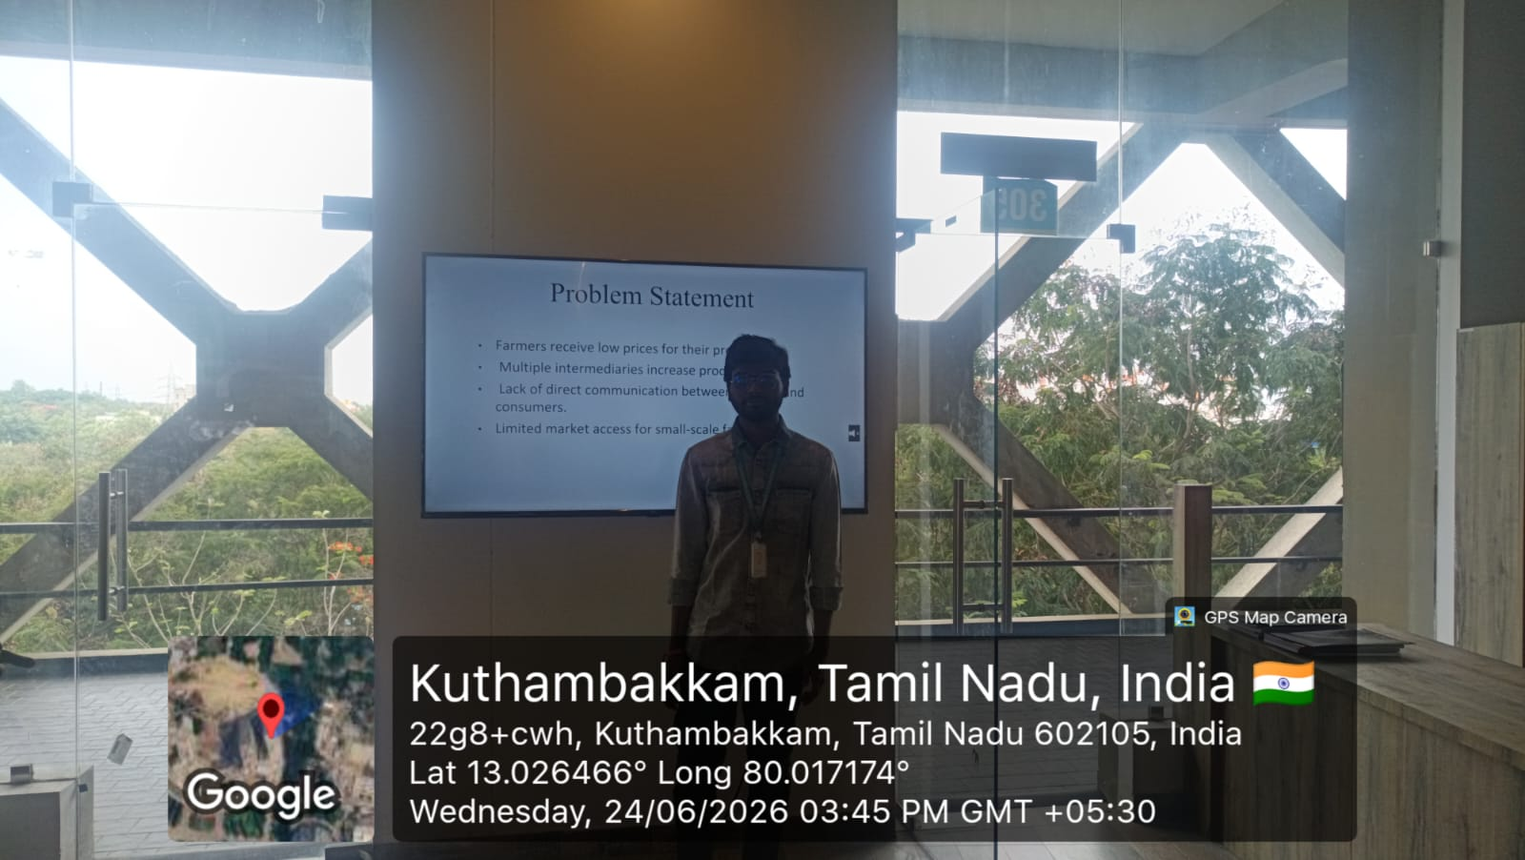

Project Description: (here you write what you did in this project (contribution) including Model Description
Agriculture plays a vital role in the economy, yet many farmers face challenges in obtaining fair prices for their products due to the involvement of multiple intermediaries. These middlemen often reduce farmers' profits while increasing costs for consumers. To address this issue, the "Agricultural Products Direct to Customers" system is proposed as an online platform that connects farmers directly with consumers.
The primary objective of this project is to create a digital marketplace where farmers can list and sell their agricultural products directly to customers. Through the platform, customers can browse available products, compare prices, place orders, and make payments online. This direct interaction ensures transparency, fair pricing, and better income opportunities for farmers while providing fresh and quality products to consumers.
The system consists of three main modules: Farmer, Customer, and Admin. Farmers can register, upload product details, manage inventory, and view orders. Customers can create accounts, search for products, place orders, and track deliveries. The Admin manages users, products, and transactions to ensure smooth operation of the platform.
The project can be developed using technologies such as Python, HTML, CSS, JavaScript, and MySQL. These technologies help create a secure, user-friendly, and efficient web application. The system reduces dependence on traditional markets and expands market access for farmers beyond their local regions.

Student Signature Guide Signature

